MINDTREE
Question
https://docs.google.com/document/d/1ZwIfa22Li657eWY-AVVI7R4jzqvODsScLAJfn7fXX_g

Solution
Cloned the github repo
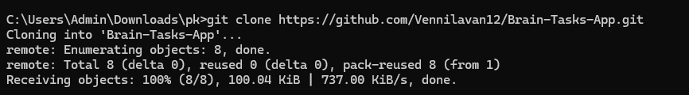
Dockerfile
Used Docker Desktop

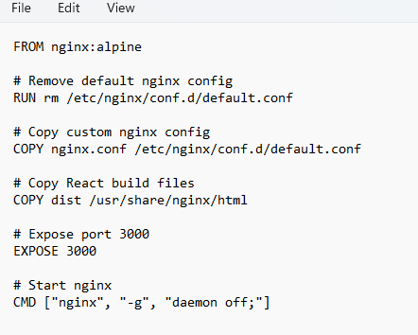
Ngnix.conf file

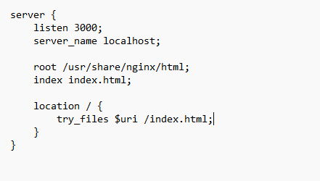
Building image and container
docker build -t reactapp:latest .
docker run -d -p 3000:3000 --name react-app reactapp:latest

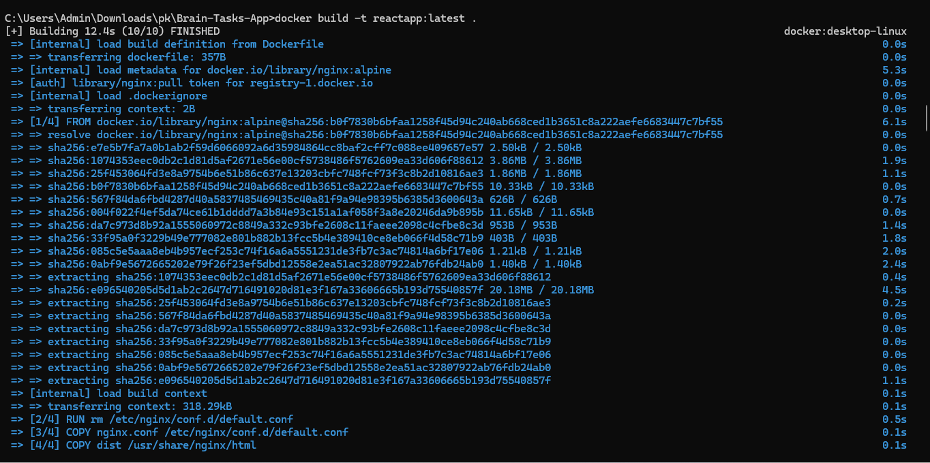

Able to open Application on port 3000 port

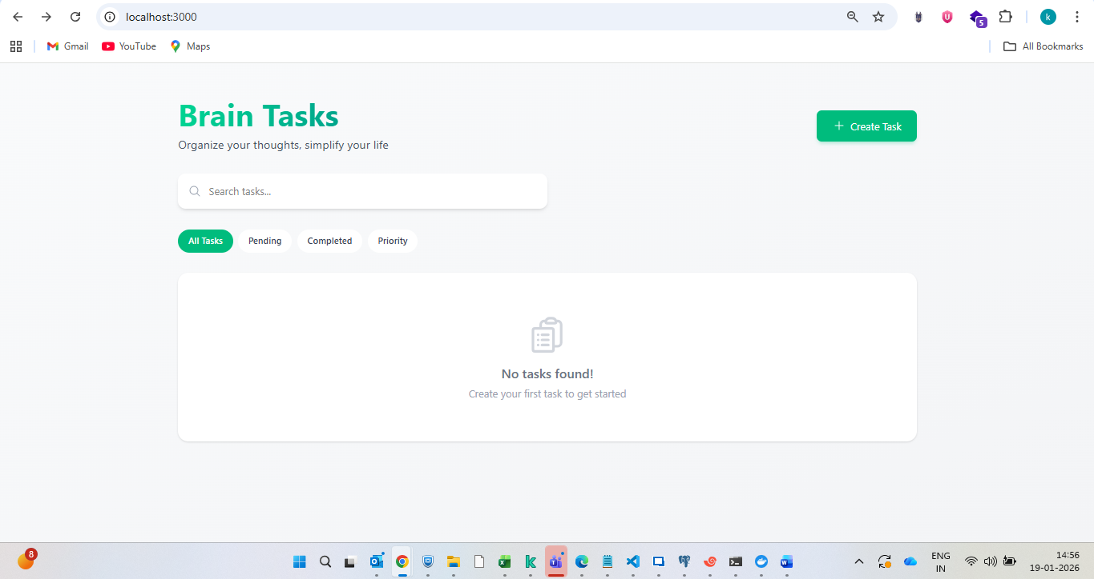
Created Private registry on ECR
Pushed the image on ECR

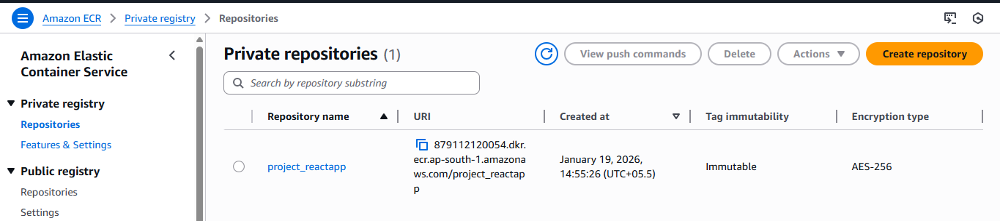
AWS configure
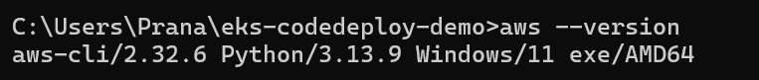
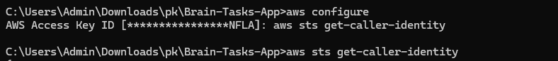
Executing push commands from ECR
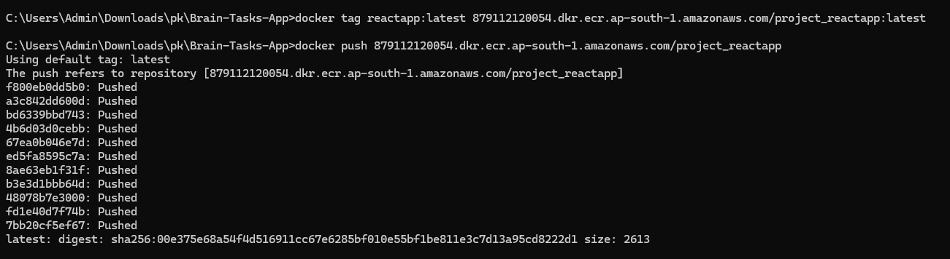
Image pushed on ECR
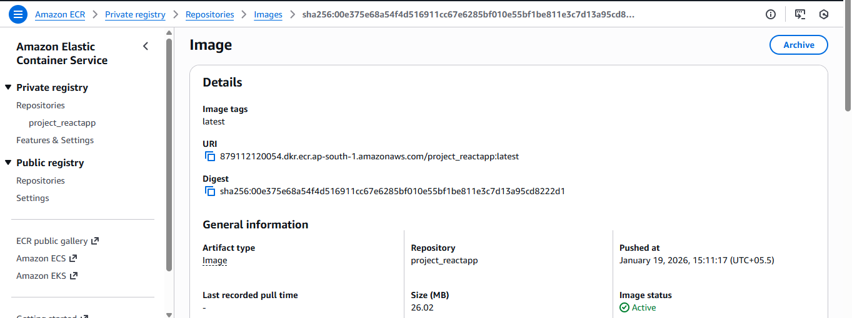
K8S EKS creation with number of nodes 2.
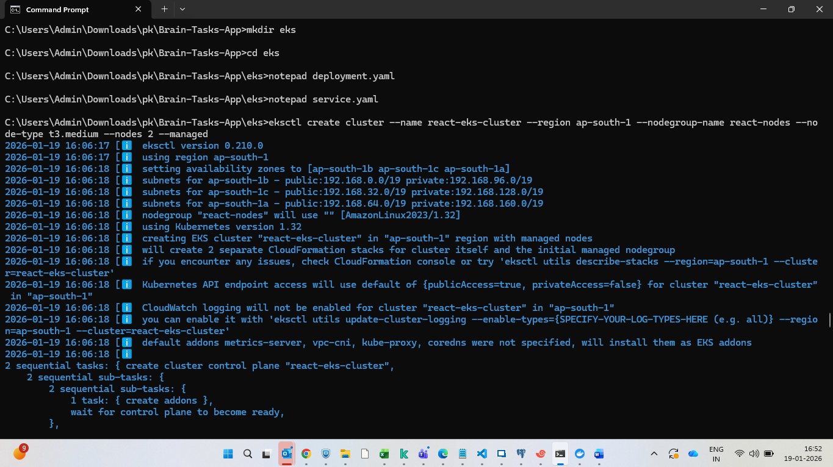

EKS Cluster -1
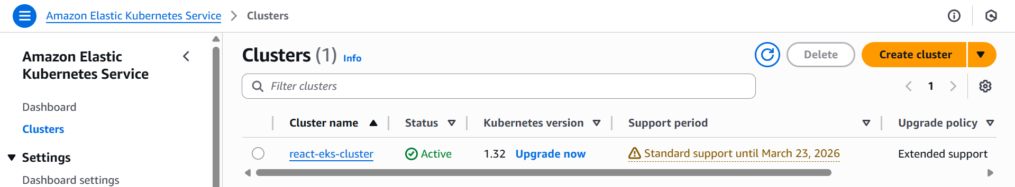
Nodes created -2
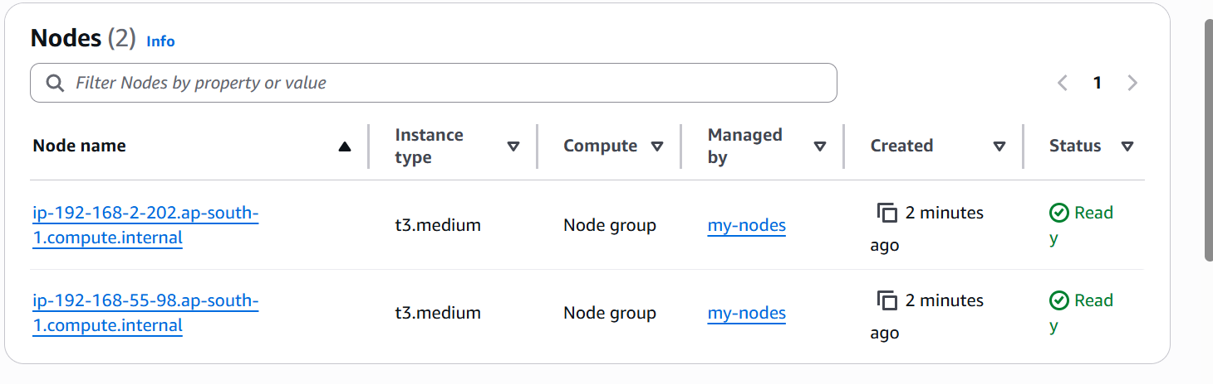
Node group -1
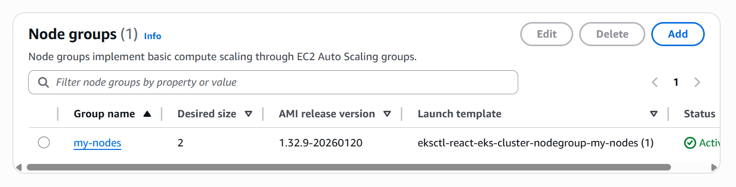

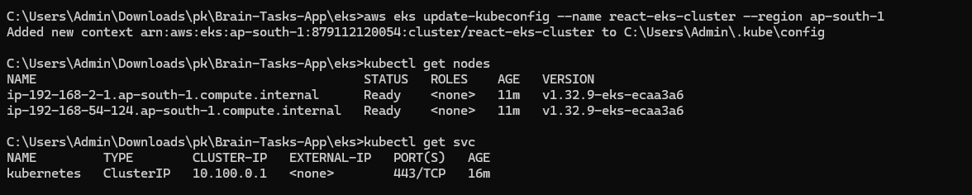
Deployment.yml
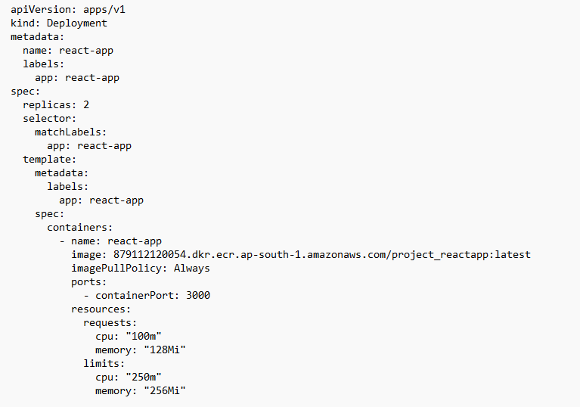
Service.yml
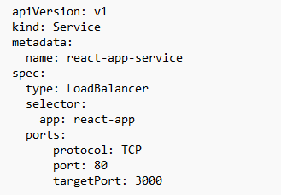
Kubectl apply -f deployment.yml
Kubectl apply -f servie.yml
Kubectl get nodes
Kubectl get pods
Kubectl get svc

Stored code in github public repo
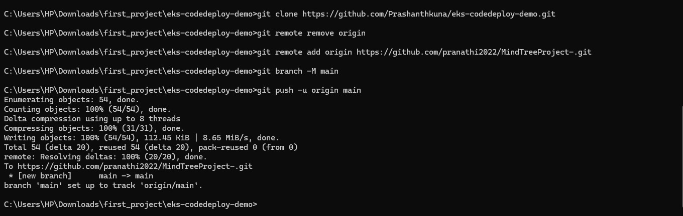
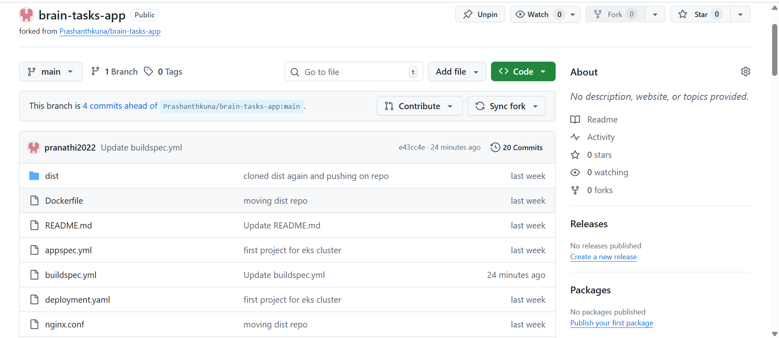
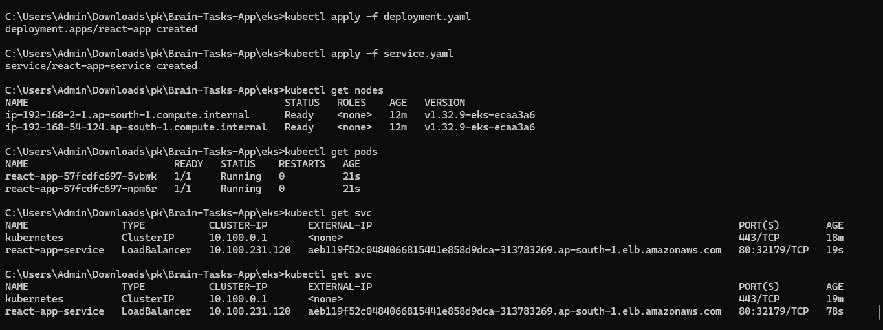
Code build
Buildspec.yml
version: 0.2
env:
variables:
AWS_REGION: ap-south-1
CLUSTER_NAME: react-eks-cluster
ECR_REPO: project_reactapp
ACCOUNT_ID: 879112120054
phases:
install:
commands:
- echo Installing kubectl...
- curl -LO "https://dl.k8s.io/release/v1.28.2/bin/linux/amd64/kubectl"
- chmod +x kubectl
- mv kubectl /usr/local/bin/kubectl
- kubectl version --client
pre_build:
commands:
- echo Logging in to Amazon ECR...
- aws ecr get-login-password --region $AWS_REGION | docker login --username AWS --password-stdin $ACCOUNT_ID.dkr.ecr.$AWS_REGION.amazonaws.com
- echo Updating kubeconfig for EKS...
- aws eks update-kubeconfig --region $AWS_REGION --name $CLUSTER_NAME
build:
commands:
- echo Building Docker image...
- docker build -t $ECR_REPO:latest .
- docker tag $ECR_REPO:latest $ACCOUNT_ID.dkr.ecr.$AWS_REGION.amazonaws.com/$ECR_REPO:latest
- docker push $ACCOUNT_ID.dkr.ecr.$AWS_REGION.amazonaws.com/$ECR_REPO:latest
post_build:
commands:
- echo Deploying to EKS...
- kubectl apply -f deployment.yaml
- kubectl apply -f service.yaml
CodeDeploy uses appspec.yml to deploy Kubernetes manifests to EKS.
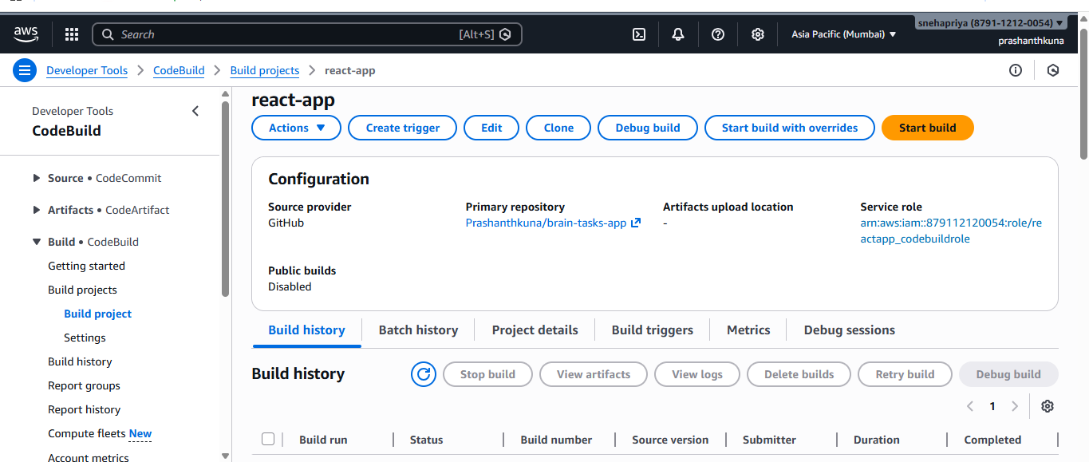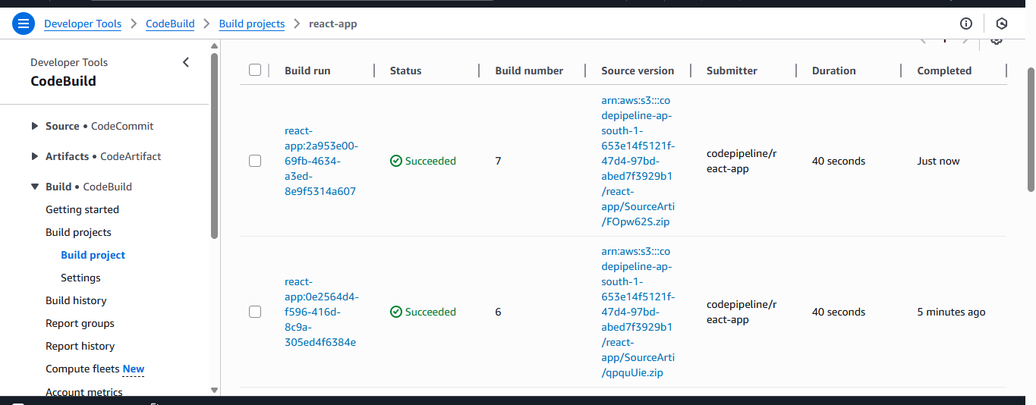
kubectl edit configmap aws-auth -n kube-system
Updated the cluster configmap with the codebuild role arn for eks access
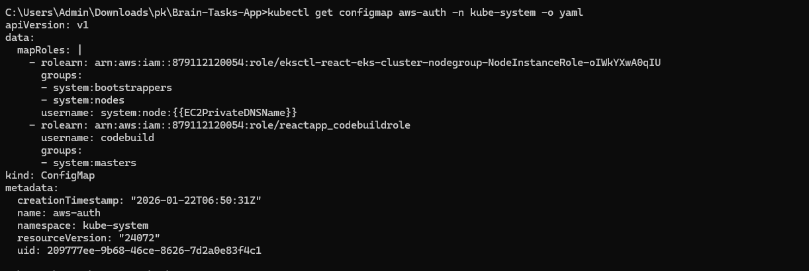

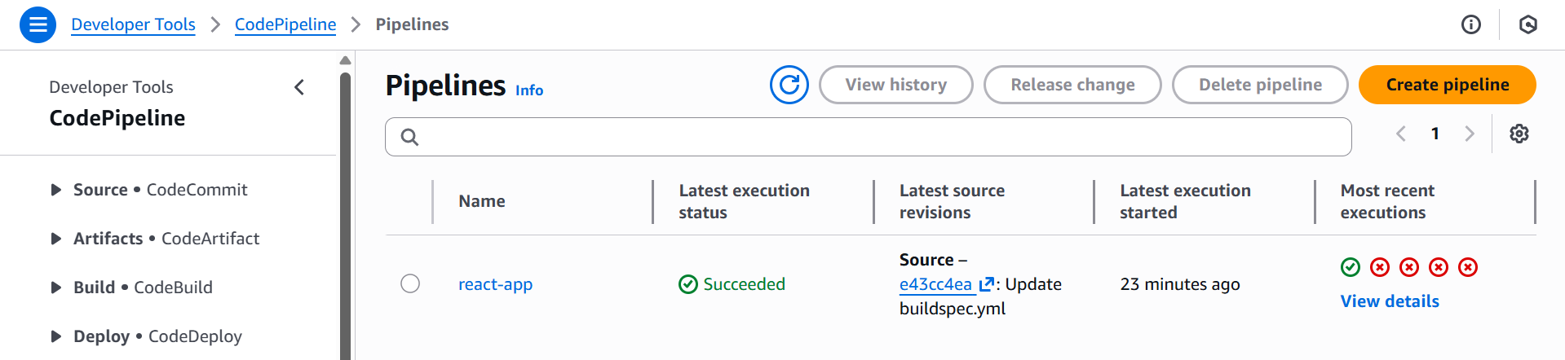

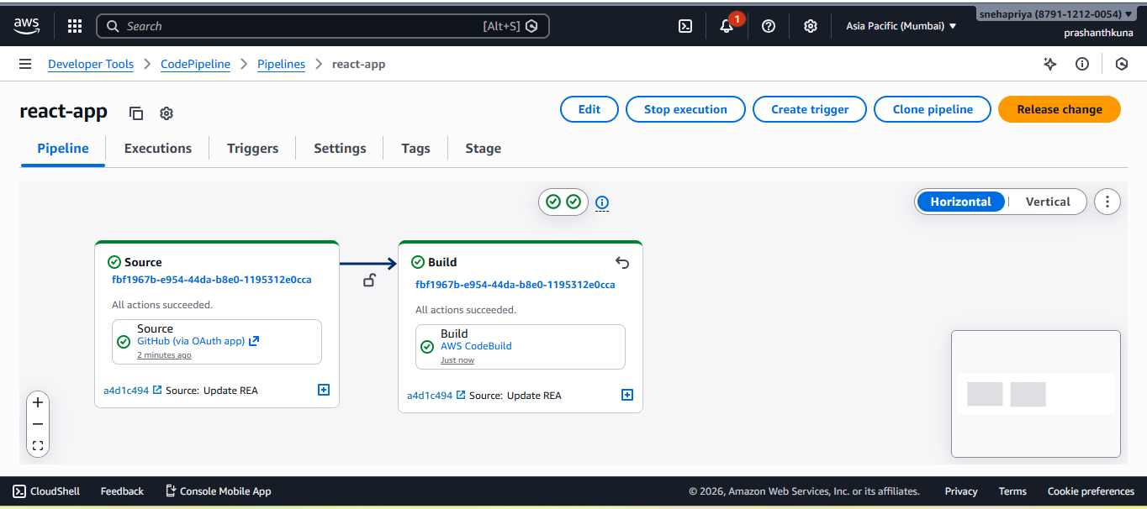
CodeDeploy Note for EKS
AWS CodeDeploy does not natively support deployments to Amazon EKS. Therefore, Kubernetes deployment was performed using AWS CodeBuild by executing kubectl commands after building and pushing the Docker image to Amazon ECR. This follows AWS-recommended practices for EKS deployments.

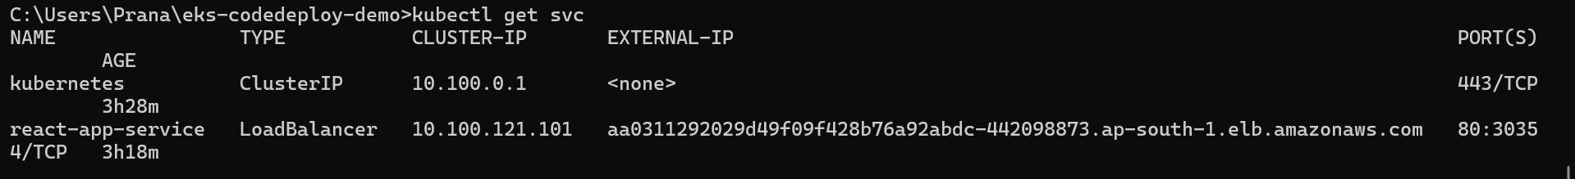
Load balancer DNS - http://aa0311292029d49f09f428b76a92abdc-442098873.ap-south-1.elb.amazonaws.com/
After deploying with Aws code pipeline accessed the app in the browser
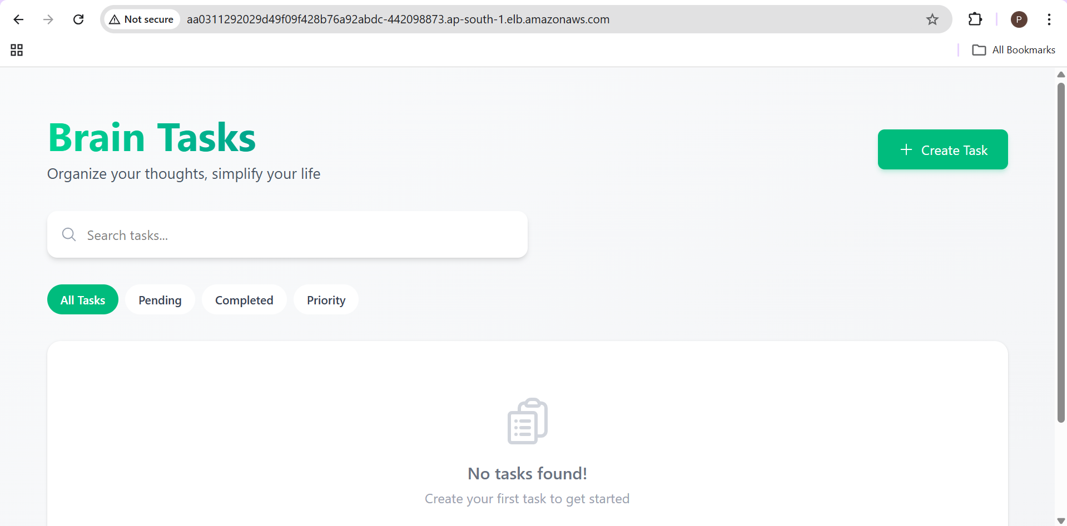
Cloudwatch Monitoring:
Monitoring:
Use CloudWatch Logs to track build, deploy, and application logs.
CodeBuild Logs
- CloudWatch → Log groups → /aws/codebuild/*

Application Logs
kubectl logs <pod-name>

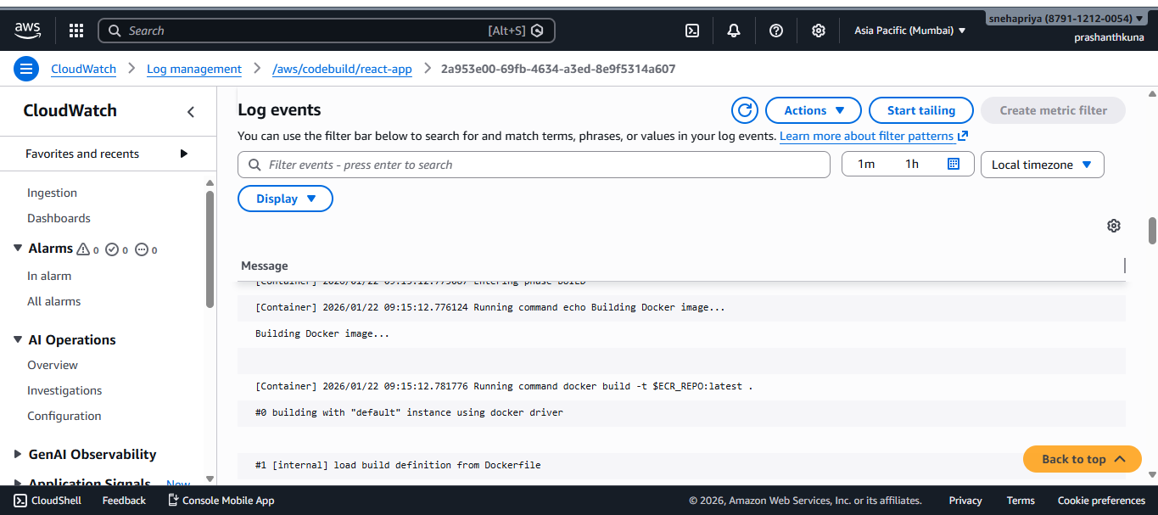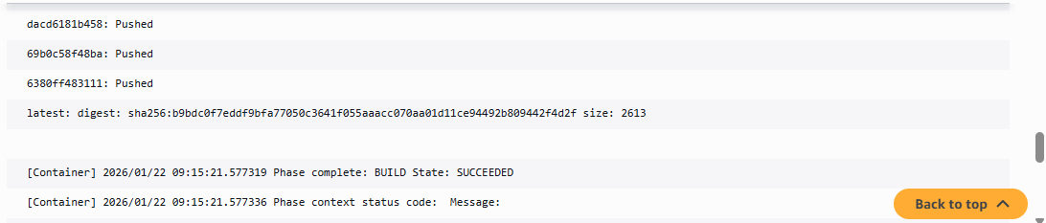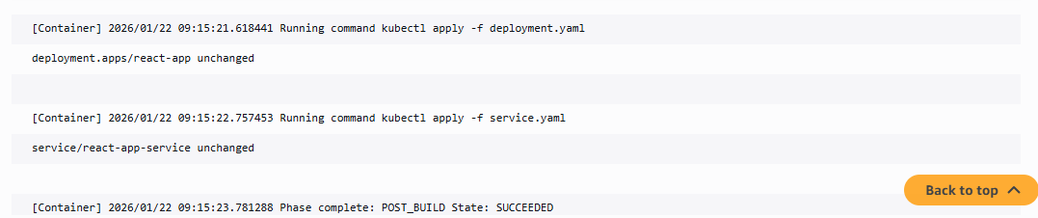
Pod logs
